Detailed Blog:

Convex Lens Simulation with Ray Tracing

Introduction to Convex Lens Simulation:

In this project, we have created a convex lens simulation with ray tracing using JavaFX. This simulation will demonstrate how light rays pass through a convex lens and create a spot diagram.

Definition: A convex lens simulation is a digital representation of a convex lens, which is a type of lens that converges light rays.

Purpose: The simulation helps to visualize and understand how light rays pass through a convex lens, making it a useful tool for optics and physics education.

Features: The simulation includes features such as ray tracing, spot diagrams, and adjustable lens parameters.

What the Demo Does and Why it's Useful:

The demo simulates a convex lens and shows how light rays are refracted through the lens. This is useful for understanding the behavior of light in optical systems and can be applied to various fields such as optics, physics, and engineering.

How Ray Tracing Works:

Definition: Ray tracing is a technique used to simulate the behavior of light rays as they pass through a lens or other optical system.

Process: Ray tracing involves calculating the path of light rays as they interact with the lens, taking into account factors such as refraction and reflection.

Importance: Ray tracing is essential for understanding how lenses work and how they can be used to manipulate light.
Step-by-Step Explanation:

1. Create Input Fields: Create input fields for focal length and aperture diameter.

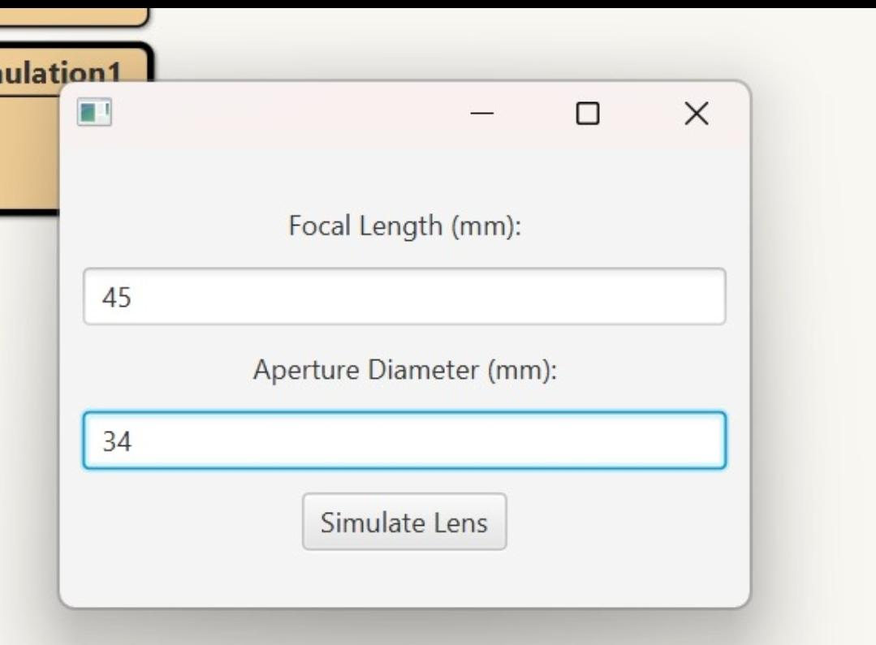

2. Simulate Lens: Simulate the convex lens and draw it on the simulation pane.

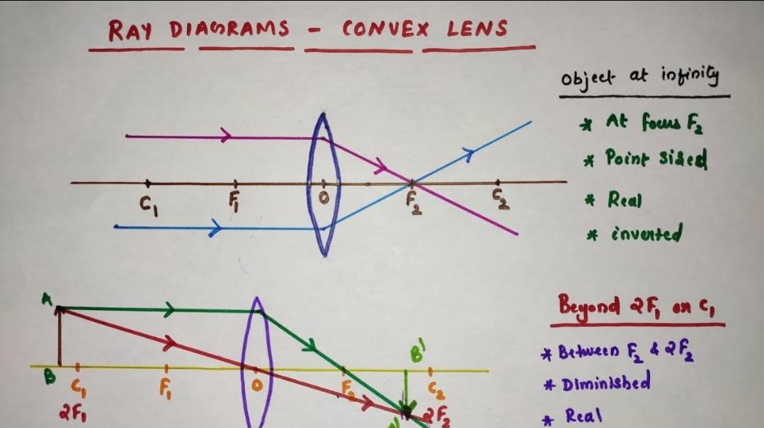
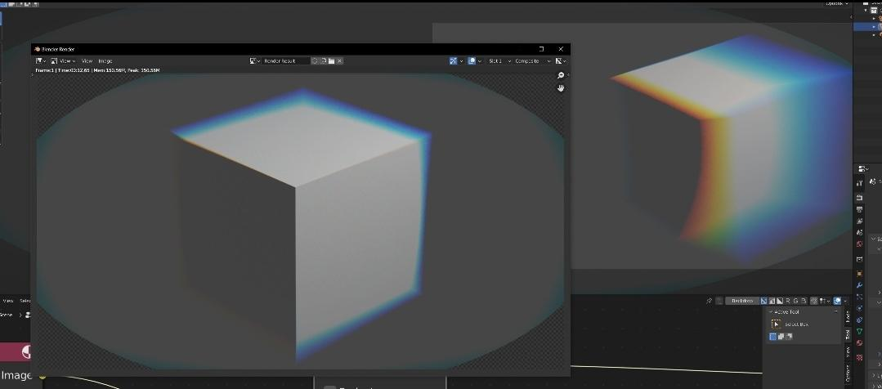

3. Simulate Light Rays: Simulate light rays passing through the lens and refract them according to Snell's law.

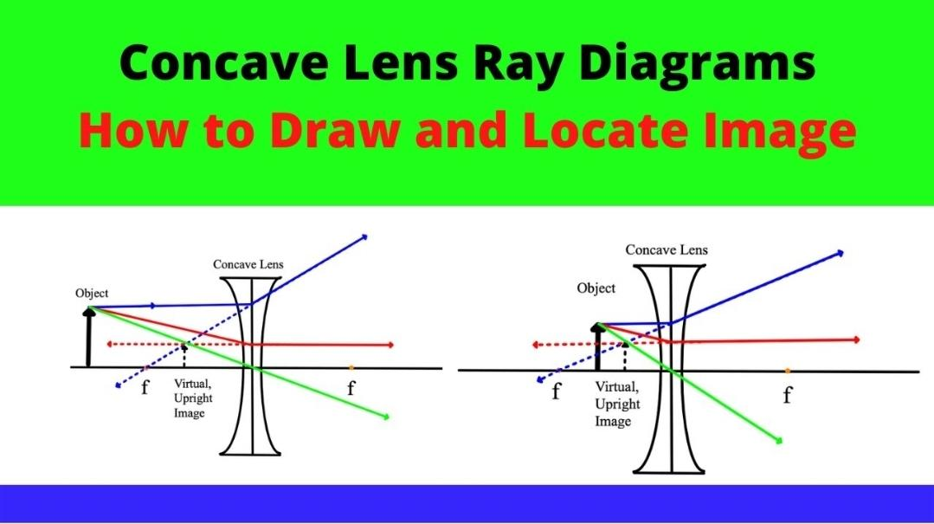

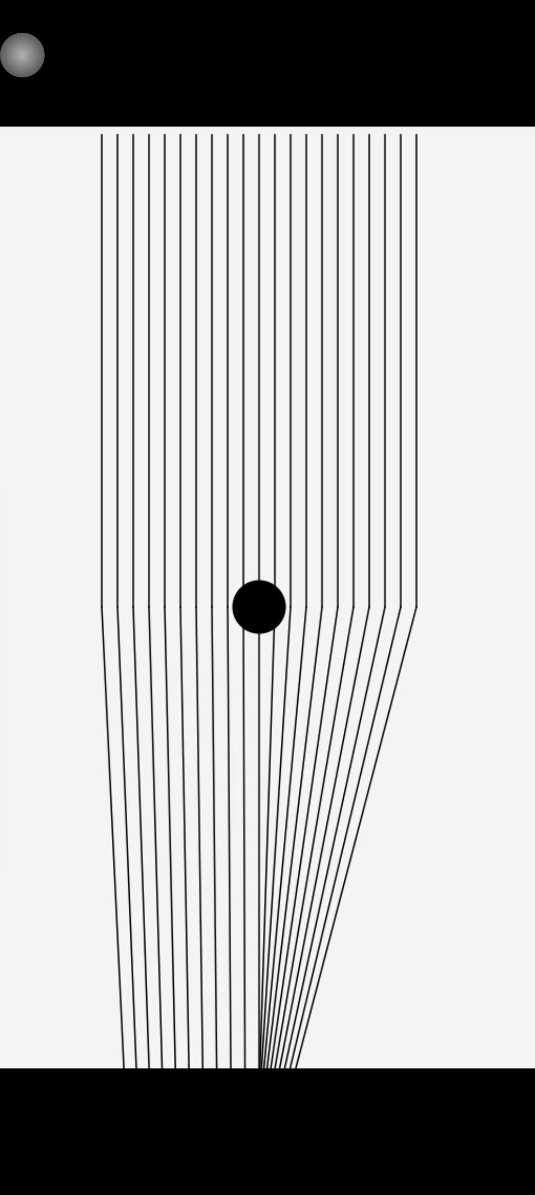

4. Create Spot Diagram: Create a spot diagram to visualize the refracted rays.

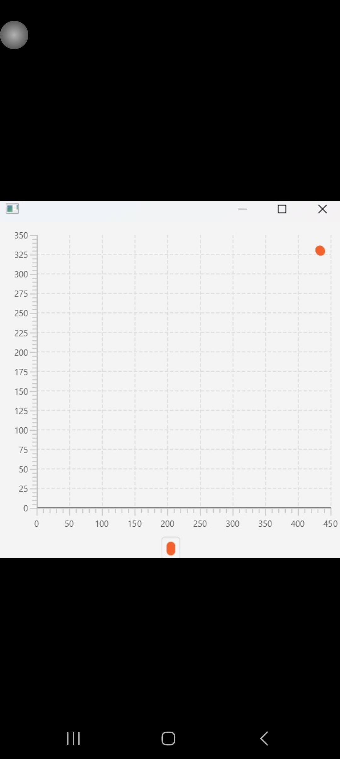

Code Snippet:

import javafx.application.Application;
import javafx.geometry.Insets;
import javafx.geometry.Pos;
import javafx.scene.Scene;
import javafx.scene.chart.NumberAxis;
import javafx.scene.chart.ScatterChart;
import javafx.scene.chart.XYChart;
import javafx.scene.control.Label;
import javafx.scene.control.TextField;
import javafx.scene.layout.HBox;
import javafx.scene.layout.Pane;
import javafx.scene.layout.VBox;
import javafx.scene.shape.Circle;
import javafx.scene.shape.Line;
import javafx.stage.Stage;

public class ConvexLensSimulation extends Application {

@Override
public void start(Stage primaryStage) {
// Create input fields
Label focalLengthLabel = new Label("Focal Length (mm):");
TextField focalLengthField = new TextField();
Label apertureDiameterLabel = new Label("Aperture Diameter (mm):");
TextField apertureDiameterField = new TextField();

// Create button to simulate lens
javafx.scene.control.Button simulateButton = new javafx.scene.control.Button("Simulate Lens");
simulateButton.setOnAction(e -> {
try {
double focalLength = Double.parseDouble(focalLengthField.getText());
double apertureDiameter = Double.parseDouble(apertureDiameterField.getText());

// Create simulation pane
Pane simulationPane = new Pane();
simulationPane.setPrefSize(800, 600);

// Draw lens
Circle lens = new Circle(400, 300, apertureDiameter / 2);
simulationPane.getChildren().add(lens);

// Simulate light rays
for (int i = -10; i <= 10; i++) {
// Incident ray
Line incidentRay = new Line(400 + i * 10, 0, 400 + i * 10, 300);
simulationPane.getChildren().add(incidentRay);

// Refract ray at lens
double angle = Math.atan2(300 - 0, 400 + i * 10 - 400);
double refractedAngle = Math.asin(Math.sin(angle) / 1.5); // assuming n=1.5 for lens material
double focalPointX = 400 + (300 - 300) * Math.tan(refractedAngle);
double focalPointY = 300 + Math.abs((400 + i * 10) - 400) * Math.tan(refractedAngle);
if (i < 0) {
focalPointX = 400 - Math.abs((400 + i * 10) - 400) * Math.tan(refractedAngle);
}
Line refractedRay = new Line(400 + i * 10, 300, focalPointX, focalPointY + 300);
simulationPane.getChildren().add(refractedRay);
}

// Create spot diagram
ScatterChart<Number, Number> spotDiagram = new ScatterChart<>(new NumberAxis(), new NumberAxis());
XYChart.Series<Number, Number> series = new XYChart.Series<>();
for (int i = -10; i <= 10; i++) {
double angle = Math.atan2(300 - 0, 400 + i * 10 - 400);
double refractedAngle = Math.asin(Math.sin(angle) / 1.5); // assuming n=1.5 for lens material
double focalPointX = 400 + focalLength * Math.cos(refractedAngle);
double focalPointY = 300 + focalLength * Math.sin(refractedAngle);
series.getData().add(new XYChart.Data<>(focalPointX, focalPointY));
}
spotDiagram.getData().add(series);

// Show simulation and spot diagram
Stage simulationStage = new Stage();
simulationStage.setScene(new Scene(simulationPane));
simulationStage.show();

Stage spotDiagramStage = new Stage();
spotDiagramStage.setScene(new Scene(spotDiagram, 400, 400));
spotDiagramStage.show();
} catch (NumberFormatException ex) {
System.out.println("Invalid input");
}
});

// Create layout
VBox inputBox = new VBox(10);
inputBox.getChildren().addAll(focalLengthLabel, focalLengthField, apertureDiameterLabel, apertureDiameterField, simulateButton);
inputBox.setAlignment(Pos.CENTER);
inputBox.setPadding(new Insets(10));
Scene scene = new Scene(inputBox, 300, 200);
primaryStage.setScene(scene);
primaryStage.show();
}

public static void main(String[] args) {
launch(args);
}
}

Creating the Simulation Pane:

JavaFX: The simulation pane is created using JavaFX, a Java library for building GUI applications.

Pane: The simulation pane is a container that holds the lens and light rays, allowing users to visualize the simulation.

Customization: The simulation pane can be customized to include features such as adjustable lens parameters and interactive controls.

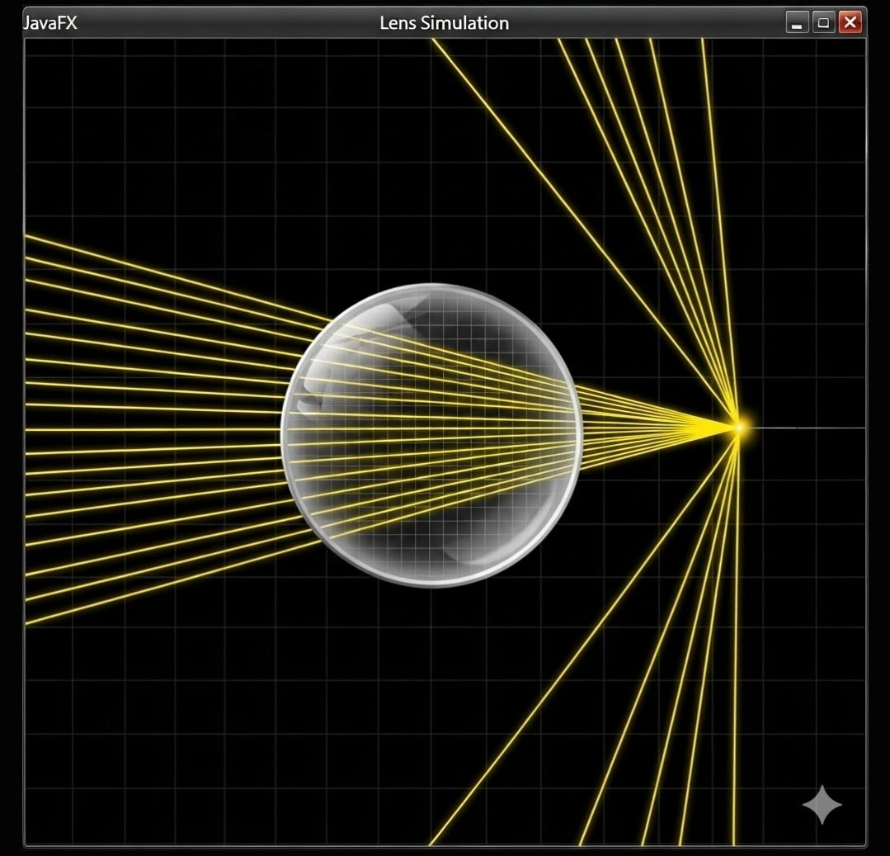

Simulating Light Rays:

Incident Rays: Light rays are simulated as incident rays, which pass through the lens and are refracted.

Refraction: The refracted rays are calculated using Snell's law, which describes how light behaves when passing from one medium to another.

Visualization: The simulated light rays are visualized on the simulation pane, allowing users to see how the lens affects the light.

Creating the Spot Diagram

Definition: A spot diagram is a graphical representation of the refracted light rays, showing how they converge or diverge.

Purpose: The spot diagram helps to visualize the behavior of the lens and how it affects the light rays.

Creation: The spot diagram is created by plotting the refracted light rays on a graph, allowing users to see the distribution of light.

Code Explanation:

Java Code: The simulation is built using Java code, which includes classes and methods for creating the simulation pane, simulating light rays, and creating the spot diagram.

Key Methods: The code includes key methods such as simulateLightRays() and createSpotDiagram(), which are used to simulate the light rays and create the spot diagram.

Variables: The code uses variables such as focalLength and apertureDiameter to define the lens parameters and simulate the light rays.

Sample output of the code:

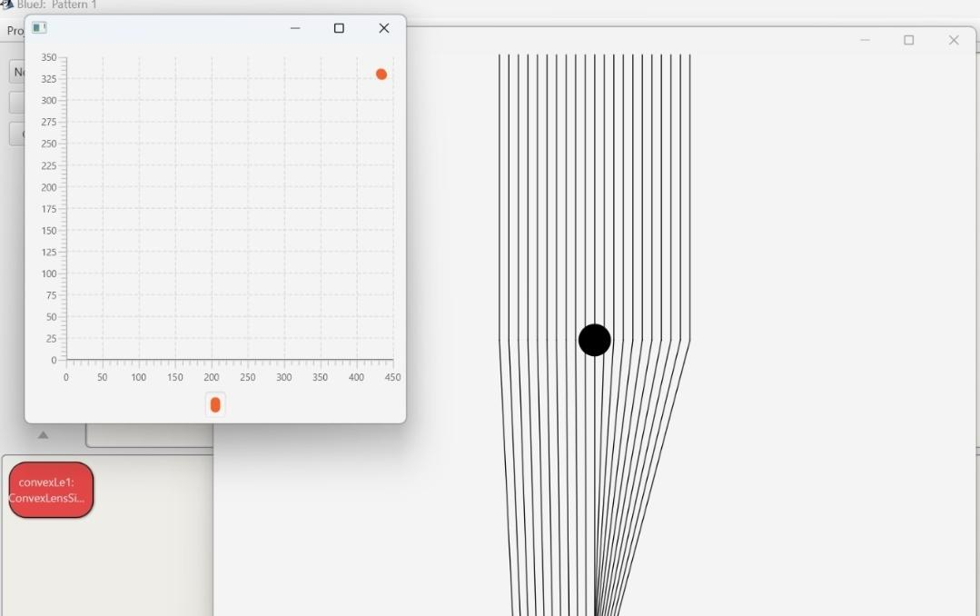

Conclusion:

Summary: The convex lens simulation is a useful tool for understanding how lenses work and how they can be used to manipulate light.

Importance: The simulation highlights the importance of ray tracing and spot diagrams in understanding lens behavior.

Future Development: The simulation can be further developed to include additional features and parameters, making it a valuable resource for optics and physics education.

Github repository link:

https://github.com/Aero637/Zeemax-optix-studio/tree/main

Project Demo Video:

https://drive.google.com/file/d/1yNOFF9GL0HkiooqT_SZbPxS5RuqOn4nO/view?usp=drivesdk

Similar to the Actual zeemax optics studio working:

https://acrobat.adobe.com/id/urn:aaid:sc:AP:28f59dd1-9b3a-46b4-92e9-8cddc91b9f78

And

https://acrobat.adobe.com/id/urn:aaid:sc:AP:e9a62f8e-4e30-42e8-be0c-d0f0931052f8

